First off, you’ll need to install EBMain, a font that replicates the font from the game Earthbound, that Project Naga used for their patch and that we’ve somewhat altered. It’s the TTF file in this folder, and you’ll need to install it. On Windows, that would mean dropping it into you Windows\Fonts folder.

After that, text insertion's mostly two phases.
1 Plan your textboxes
2 Write your textboxes

Phase one involves dumping your script in FE4TextBoxFormat.odt.

The text will need to be pasted in the boxes in there, making sure it's in the Earthbound font, so... EBMain 24pt, etc.
Depending on whether your dialogue is indoors, outdoors, or battle text, you’ll need to pick the correct box, as outdoors textboxes are slightly smaller, and battle ones are way smaller.
These boxes will be your guides to how long the lines are.

So you dump all of it in there, and now you need to start planning the textboxes.
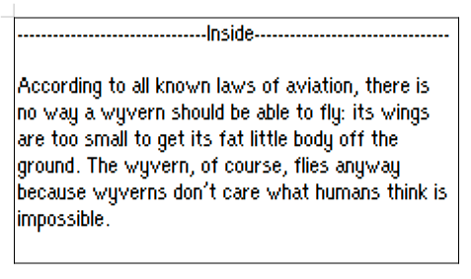
If this is world map exposition textboxes, it's only two lines long, so you can do this:
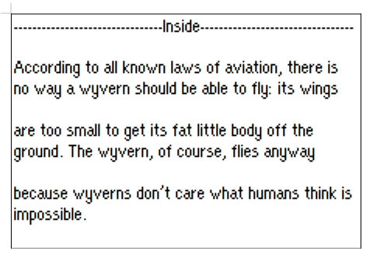
But the line breaks aren't very clean
There's that lone "there is", you stop in the middle of sentences... it's meh.
So you start breaking the lines in smarter places, like this:
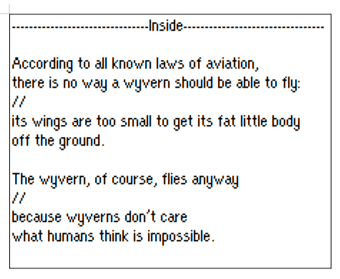
It’s better to cut to a new line on a punctuation mark, or between important units of meaning.
The // marks indicate that the sentence continues, which means there will be a pause for the reader (WaitForA command), instead of a textbox wipe (ScrollText/ScrollBoth). They are purely indicative and won’t need to be inserted into the text files.

Sometimes, you might need to place a WaitForA in the middle of a line. Here, for instance, we have a battle quote, so three lines at a time. That colon looks very tempting:
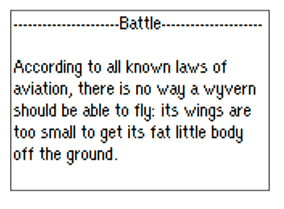
So you could either do this:
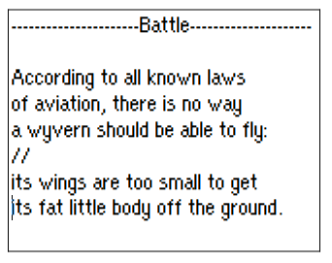

Or this:
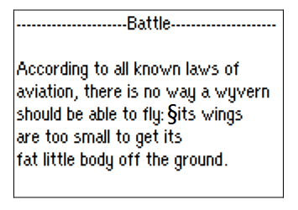
This § is what I use to demote that a textbox will have a pause (the one where it's waiting for you to press A) in the middle of a line. I use that because it's about as large as a space, so it doesn't throw my length limit out of whack. You can use something else, as long as you remember what it is you use to mark mid-line breaks.
In practice, this is what this would look like in game:
According to all known laws of
aviation, there is no way a wyvern
should be able to fly: ▼
Then, press A, the game scrolls down two lines, then writes:
should be able to fly: its wings
are too small to get its
fat little body off the ground. ▼

Honestly, the first setup (3 lines + 2 lines) looks better than this one (2.5 lines + 2.5 lines). But I needed an example for mid-line WaitForA.
There's a lot of different ways to split a bunch of text. It's up to preference. Generally, it's better to avoid mid-line breaks, unless you just... have a dialogue sentence that takes 4 lines on its own.

And that’s what you’ll need to do for all your text, and it'll eventually be all nice and separated into textboxes.
It's honestly not very high-concentration work, so a good thing to do with like, videos or podcasts running in the background.

Phase 2, we open the files and put the text in it!
It’s all in the Dialogue folders, in .asm files, which you can open in a regular text editor like Notepad++ or Sublime.
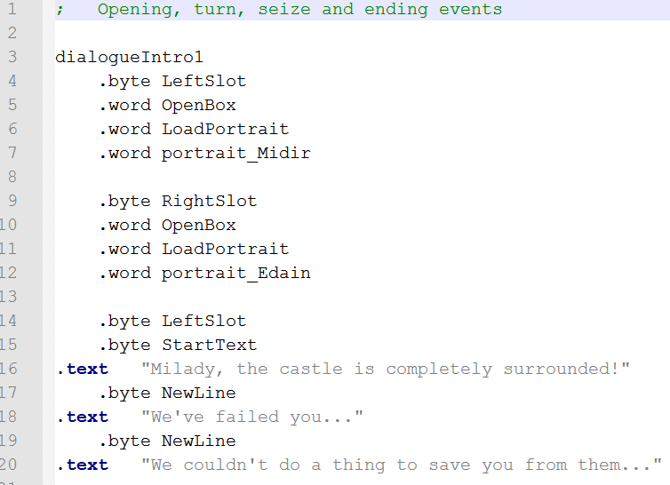
Most of the syntax is fairly self-explanatory. Since we already did all the portrait stuff, you will rarely need to worry about spawning portraits, despawning them, which side they're facing, etc.

So if you’re translating or lightly editing, these aren’t important for your purposes:
.byte LeftSlot
.word OpenBox
.word LoadPortrait
.word portrait_Midir
If you want the list of commands, you can check the ControlCodes.asm file.

Every line of text is a
.text "yourtexthere"
If you forget the "s, the build files will yell at you in the log.

A basic text box looks like this:
.text "Yellow, black. Yellow, black. Yellow, black."
.byte NewLine
.text "Yellow, black. Ooh, black and yellow!"
.byte NewLine
.text "Let's shake it up a little."
.byte WaitForA

Then you put a
.byte ScrollText
Somewhere between this and the next textbox. Either after your WaitForA, or right before the next textbox. WaitForA being the thing that makes the text stop and wait for you to read.
A lot of it will just be replacing our words with your own, and you'll familiarize yourself as you go.

The only actual tricky part is doing mid-line breaks (which is why you want to avoid them, as they're a bit annoying to format)(also they don't look great ingame either)
Here, the format will be
.text "According to all known laws of aviation,"
.byte NewLine
.text "there is no way a wyvern should be"
.byte NewLine
.text "able to fly:"
.byte WaitForA
.text " its wings are too small"
.byte NewLine
.text "to get its fat little body off the ground."
.byte WaitForA
Do note the space in .text " its wings are too small". Since you put a comma before the WaitForA, you need that space after.

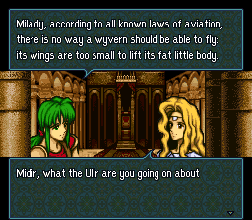
And that's the gist of it.
All the text files you'll be inserting into have a label for the convo, like dialogueIntro1, that gets referenced in the Pointers files.

If you’re not sure, feel free to send me your first attempts, and I’ll proofread it and give you some feedback.
And after that, I'm pretty sure you'll be able to handle the rest of it, honestly.

